Activity - ISSYP Investigating the Nature of the Electron

Part 1: Classical Particle Behaviour
In this activity, you will use the double-slit experiment to investigate the nature of classical objects and classical waves and
compare them to electrons.

Experiment
In this activity, you will pour sand through two narrow slits, 1.0 cm apart, cut into the bottom of a paper cup. The cup should have a small rim
which suspends the slit a few millimetres above the paper.
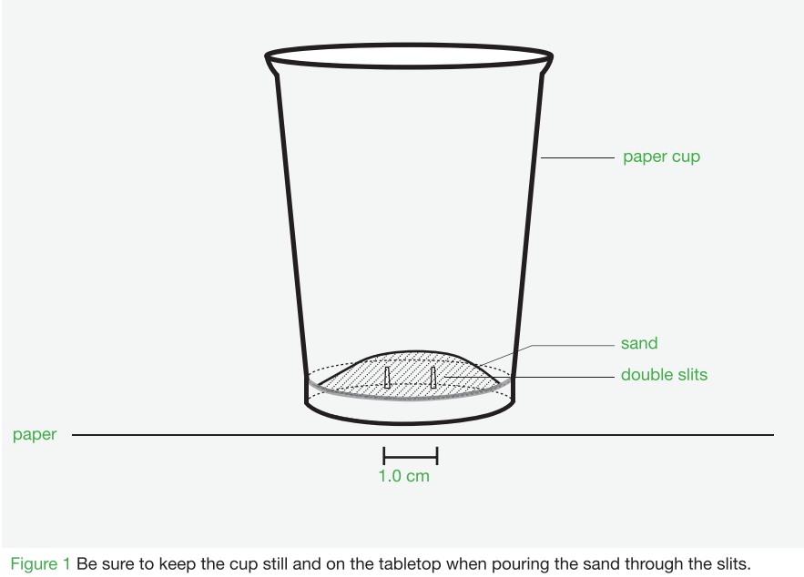

Prediction
(i) Sketch your prediction of how the sand will pile up after it has passed through the slits. Draw the proﬁle of the sand as it
would look when viewed from the side. Show the slits in your diagram.
(ii) Provide reasoning for your prediction in one or two sentences.
Prediction
Reasoning

Procedure
Rest the paper cup with the slits in the bottom on a sheet of white paper. Carefully pour a small amount of sand into the cup and tap it gently to allow some of the sand to pass through the slits (see Figure 1).

Observations and Explanations
1. Sketch a proﬁle of the pile of sand.
2. Does the proﬁle of the sand match your prediction? Why does the sand form the observed shape?
3. Grains of sand are localized particles. How do two grains of sand interact when they arrive at the same location at the same time?
4. Make a general statement about how classical localized particles behave when passing through a double-slit apparatus and describe the pattern they make after they have passed through the apparatus.

Part 2: Classical Wave Behaviour
Waves behave differently from particles. Before proceeding, recall how waves interact by studying the diagrams below, which
show constructive and destructive interference.

Experiment
In this activity, you will model waves passing through two slits using waves drawn on transparencies. You will observe and
record how these waves interact when they meet at a screen 15 cm away from the slits.

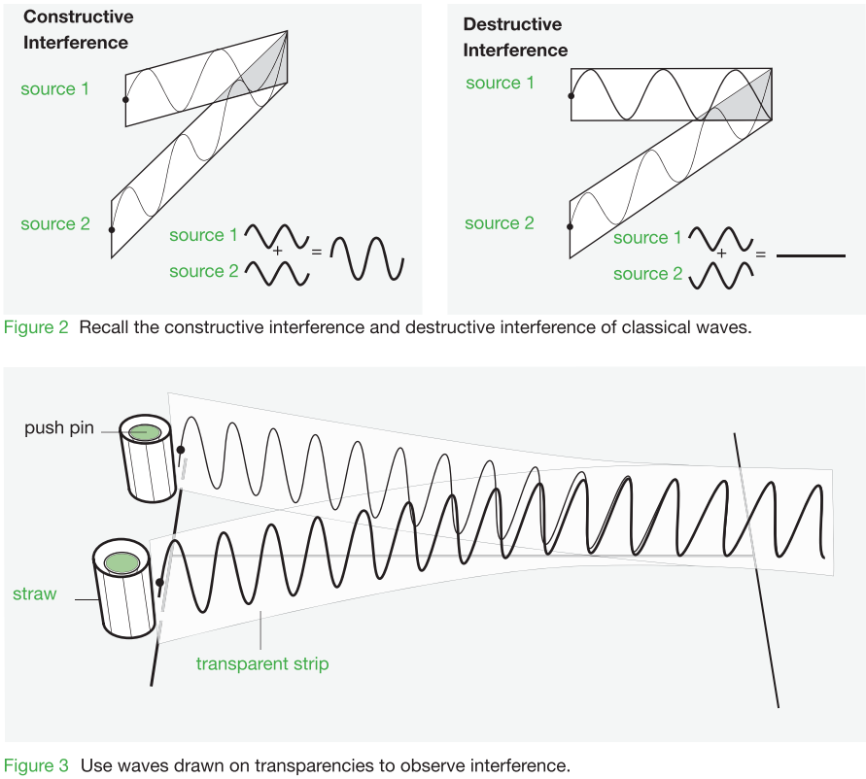

Notice:
Both waves are in phase at the source

Prediction
(i) Sketch your prediction of how the two waves will interact when they meet at various locations across the screen. Clearly
label regions of complete constructive and destructive interference.
(ii) Provide reasoning for your prediction in one or two sentences.
Prediction
Reasoning

Procedure
(i) Place wave A on the push pin centered on Slit A. Place Wave B on the push pin centered on Slit B.
(ii) Arrange the transparencies so that they meet at the screen.
(iii) Start at one side of the screen and move along to the other side. Place a C on the screen indicating the places where total
constructive interference happens and a D where total destructive interference happens (see Figure 3).

Observations and Explanations
1. Sketch and label the pattern of constructive and destructive interference.
2. Compare the pattern with your prediction. Explain any discrepancies between your prediction and the experimental observations.
3. Waves are not localized, they are spread out. How do two waves interact when they arrive at the same location at the same time?
4. Make a general statement about how classical waves behave when passing through a double-slit apparatus and describe the pattern
they make after passing through the apparatus.

Part 3: Light Behaviour
In 1807, Thomas Young published results from a double-slit experiment conducted with light. At the time, his results seemed
to solve the debate about whether light was a particle or a wave.

Experiment
In this activity, you will shine a laser through two narrowly spaced slits and onto a distant screen.
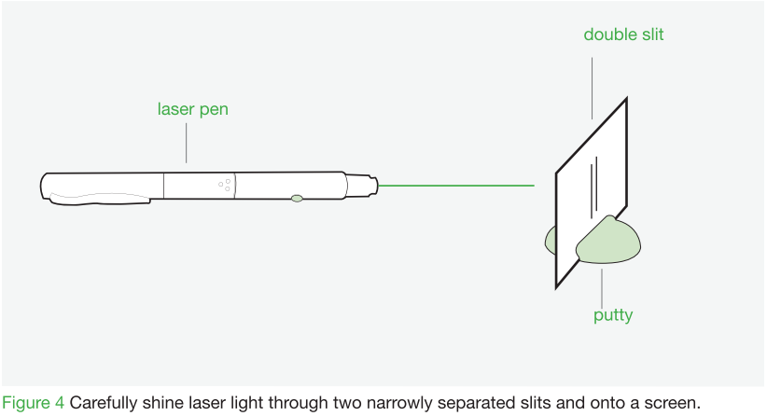

Prediction
(i) Sketch your prediction of how the light will appear on the screen after passing through the two slits.
(ii) Provide reasoning for your prediction in one or two sentences.

Reasoning
Prediction

Procedure
(i) Carefully shine laser light through two narrowly separated slits and onto a screen as illustrated in Figure 4.

Observations and Explanations
1. Sketch the resulting image on the screen.
2. Compare your results for light with those for the sand and the waves modelled with transparencies. Based on this
comparison, formulate an argument that describes light either as a wave or a particle. Include diagrams.

Part 4: Electron Behaviour
An electron is often described as a particle. This idea can be tested by passing electrons through a double-slit apparatus.

Experiment
In this activity, you will predict how electrons behave when passing through a double-slit apparatus. After making your prediction,
you will be provided with data from the actual electron double-slit experiment.
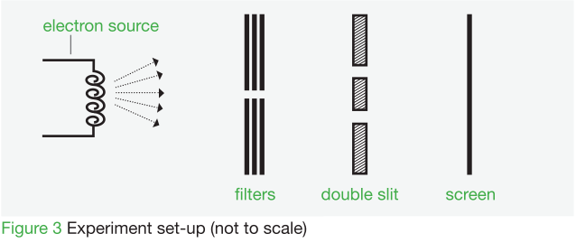

Prediction
(i) Sketch your prediction of how the electrons will appear on the screen after passing through the double slits. Assume
enough time has elapsed for several thousand individual electrons to pass through the apparatus.
(ii) Provide reasoning for your prediction in one or two sentences.
Prediction
Reasoning

Procedure
Once you have recorded your prediction turn to the next page for the results. The images in Figure 5 were produced by sending individual electrons through a double slit. Each dot represents an electron striking the detection screen. Carefully analyze the image data to help you answer the questions.

Observations and Explanations
1. Consider image (d). How accurate was your prediction? What assumptions did you make when developing your prediction
that lead to its relative accuracy or inaccuracy?
2. How does the data support a wave-behaviour description of the electrons?
3. How does the data support a particle-behaviour description of the electrons?
4. Carefully consider the observed electron data. Is it possible to determine whether electrons exhibit strictly wave or particle
behaviour? Explain your reasoning as completely as possible with direct reference to the image data and the general
statements you made in Part 1 and Part 2 of the activity.

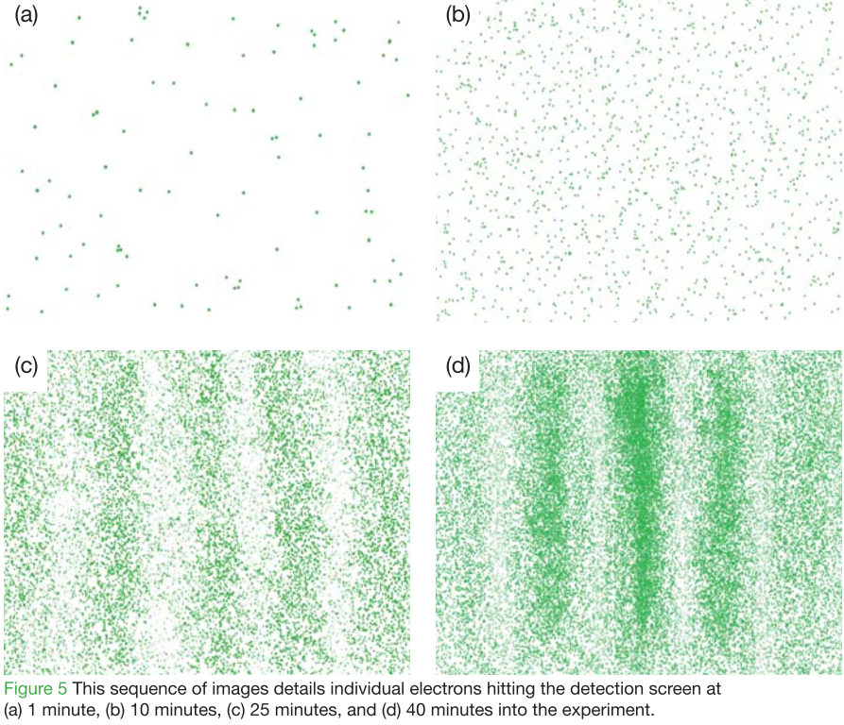

Part 5: Summary

1. Construct a summary chart comparing the particle-like behaviour and wave-like behaviour of electrons in the double-slit
experiment. Be as detailed as possible.
2. Use your chart from question 1 to analyze the results for light passing through two slits. According to your summary, is
light best described as a particle or a wave? Support your conclusion with a clear statement.
3. Use your chart from question 1 to analyze the results for electrons passing through two slits. According to your summary,
are electrons best described as a particle or a wave? Support your conclusion with a clear statement.
4. Are you comfortable with the statement that you have made about the nature of electrons? Does it agree with your current
understanding of the electron?
5. Describe what is meant by the phrase, “Electrons exhibit wave-particle duality.”
6. The electron double-slit experiment creates a dilemma for us. How can individual electrons produce an interference
pattern? Develop your own explanation for what the electrons are doing as they pass through the apparatus. Summarize
your explanation in two or three sentences.
7. The electron double-slit experiment challenges our understanding of nature. In this experiment we have an object acting
as both a wave and a particle. Imagine you are going to explain this to your family tonight at dinner. Write a paragraph
describing the results of the electron double-slit experiment and your conclusions, using language that they will
understand. Be prepared to report back to class tomorrow about the success of your tutorial.
8. This activity provides insight into how difﬁcult it is to describe quantum phenomena using classical ideas about particles
and waves. Undoubtedly, the result of the double-slit experiment for single electrons has left you with some intriguing
questions. Generate a list of three to ﬁve questions about the wave-particle duality of quantum objects. Compare your list
with a partner, and be prepared to share some of your questions with the class.

